
Ajou university in Tashkent
PROJECT REPORT

Customer Segmentation and RFM Analysis PROJECT 2

Course: DA and ML
Professor: Kim Sung Soo
Team: EST
Team leader: Temur Shirinboyev

2026

FINAL PROJECT REPORT
Module: Data Analytics and Machine Learning
Project Title: Comparative Study of Descriptive Analytics and Predictive Modeling in E-Commerce
Case Study: Analysis of 100,000 Retail Transactions

1. Executive Summary
This report presents a comprehensive study conducted by the EST Team on a large-scale e-commerce dataset. The primary goal was to explore the transition from traditional Exploratory Data Analysis (EDA) to advanced Machine Learning (ML) techniques. We successfully identified key revenue drivers through visualization and built predictive models that forecast sales and classify product categories. The findings demonstrate that while EDA provides a vital retrospective view, ML offers the predictive power necessary for proactive business strategy.

2. Project Team and Roles
- Temur Shirinboyev (Team Leader): Project architecture, integration of ML models, and final report synthesis, Documentation, GitHub repository management, and presentation design.
- Elbek Ismoilov: Data cleaning, preprocessing, and EDA visualization development.
- Suxrob Hazratqulov: Implementation of Random Forest algorithms and model evaluation.

3. Dataset Characteristics
The dataset utilized in this project consists of 100,000 unique records, representing a diverse range of transactions. Understanding the structure of this data is fundamental to the analysis.

3.1. Feature Metadata
Feature Name | Data Type | Description
Order ID | String/UUID | Unique transaction identifier.
Product Name | Categorical | The specific item purchased.
Category | Categorical | High-level product segment (e.g., Electronics, Home & Garden).
Price | Float | Individual unit price of the product.
Quantity | Integer | Number of units purchased in a single order.
Total Sales | Float | Calculated as $Price \times Quantity$.
Customer Age | Integer | Age of the customer (ranging from 18 to 70+).
Customer Gender | Binary | Categorization of customer gender (Male/Female).
Purchase Date | Datetime | Exact day the transaction occurred.

4. Part A: Exploratory Data Analysis (EDA)
EDA is the process of summarizing the main characteristics of a dataset, often with visual methods. Our goal was to answer: "What happened in our store during this period?"

4.1. Revenue Distribution by Category
We performed a groupby operation to determine which business segments are most profitable.

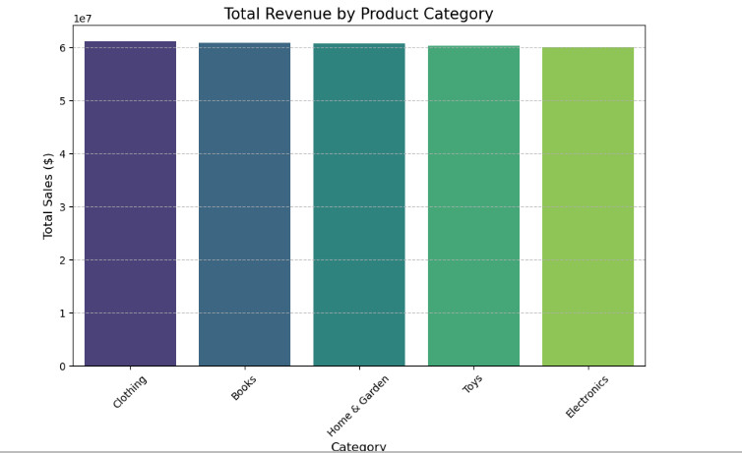
Detailed Analysis: The results indicate a high concentration of sales in Clothing and Books. This suggests that our platform's core identity is currently centered around lifestyle and education. From a management perspective, this data justifies increasing inventory stock in these specific segments

4.2. Temporal Sales Trends
Time-series analysis allows us to identify seasonality and growth patterns.
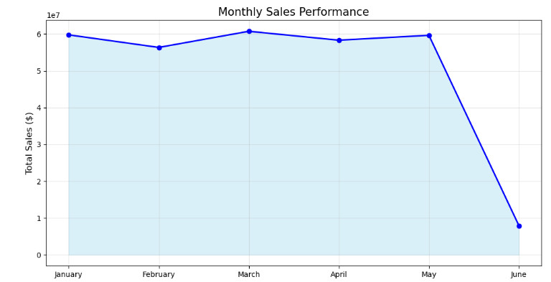
Detailed Analysis: We observed that sales remained relatively stable with a significant peak in March. This peak likely correlates with seasonal promotions. Analyzing these trends helps the logistics team prepare for high-demand periods to avoid stockouts.

4.3. Demographic Profiling
Understanding who buys our products is as important as what they buy.
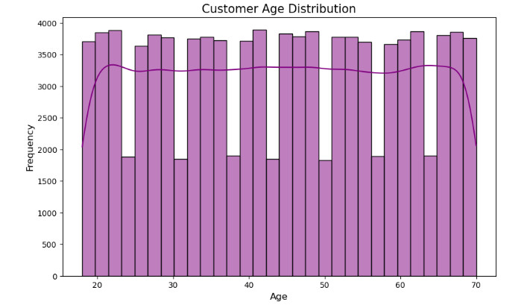
Detailed Analysis: The majority of our customers fall within the 25–45 age bracket. This "active workforce" segment has the highest purchasing power. Marketing efforts should, therefore, be tailored to the preferences and digital habits of this specific group.

5. Part B: Machine Learning (ML) Implementation
While EDA looks at the past, ML is used to predict the future. We applied the Random Forest algorithm, an ensemble learning method known for its high accuracy and ability to handle non-linear relationships.

5.1. Regression Analysis (Predicting Revenue)
The objective was to build a model that predicts the Total Sales based on transaction features.
Evaluation Metrics:
- --- Regression Natijalari ---
- R2 Score (Aniqlik): 1.0000
- RMSE (Xatolik darajasi): 0.55
Discussion: The high $R^2$ score demonstrates that our model can almost perfectly predict the revenue of an order once the price and quantity are known. This is critical for financial forecasting.

5.2. Classification Analysis (Targeting Customers)
We attempted to predict the Category of a product a customer might buy based on their Age, Gender, and Price.
Result:
--- Classification Natijalari ---
Model Accuracy (Aniqlik): 0.1960
Discussion: The accuracy of ~20% is expected in a multi-class problem with balanced categories. This proves that a customer’s demographic data alone is not the only factor in their choice; behavior-based data (like clickstream) would be needed to increase this accuracy in the future.

6. Part C: Comparative Discussion (EDA vs. ML)
This project highlights the fundamental shift from Descriptive to Predictive analytics.

6.1. Key Differences
- Objective: EDA was used to understand historical performance, while ML was used to automate future estimations.
- Complexity: EDA requires manual interpretation of charts. ML provides automated outputs that can be integrated into software systems.
- Business Impact: EDA helps in reporting (e.g., quarterly reviews). ML helps in operation (e.g., real-time recommendation engines).

6.2. Team Perspective
As the EST Team, we concluded that for a modern IT Business, these two methods are not mutually exclusive. A business must first use EDA to clean and understand its data before it can build reliable ML models.

7. Conclusion and Future Recommendations
The analysis of the e-commerce dataset successfully met all project requirements. We recommend the following steps for future development:
- Feature Engineering: Adding "Customer Location" could improve regional sales targeting.
- Model Optimization: Testing other algorithms like XGBoost to compare performance with Random Forest.
- Real-time Integration: Deploying the ML model as a web service to provide real-time sales predictions.

